### Inf 43 – Fall Session, 2013 – Big Assignment 3

##### Student Name: Ford Tang

#### Student Number: 46564602

###### General principles for user interface design analysis of Amazon.com

4 Relevant Heuristics:

1. Aesthetic and minimalist design – Amazon.com is built to be a pure consumer shopping experience. Each page is laid out in a way to sell and inform the user about a product. Very streamlined and without any other unnecessary information.
2. Match between system and the real world – With the amount of products available on Amazon.com, the language that is displayed for the user must be clear and easy to understand. This allows the user to navigate around the site easily and find what they are looking for. Amaazon.com does this with amazing efficiency by utilizing every day, easy to understand words and phrases.
3. Consistency and standards – To keep users from being overwhelmed and getting lost in the endless pages of products, Amazon.com uses a very structured and consistent design for each page. This allows the user to quickly understand where they are and where they can go at any one time.
4. Recognition rather than recall – Along with the consistency of the design, each page is made so that the user does not need to recall where they are to understand what is displayed. As a user navigates the pages of Amazon.com, the website displays the area at which they are currently in and where they came from. If the user uses any filters, it displays them along the top and sides so the user knows what is active and can disable them if necessary without recall.

Analysis of 4 Heuristics

1. Help and documentation

  
  
Amazon.com provides 2 available links to their help section. One on top and one at the bottom. While it works, the help given is generic as it is not relevant to what the user is currently doing. If Amazon.com provided contextual help, or help tips on certain sections it could be better for the user overall.

1. Visibility of system status  
   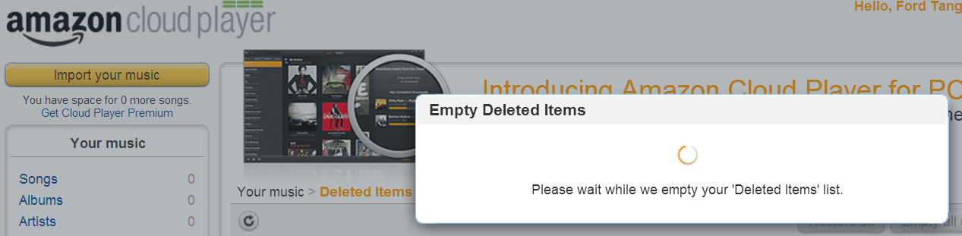  
   Amazon.com is very fast so most of the page loads does not require a notification. I loaded a few songs into the Amazon cloud player and proceeded to delete them and I was given the generic Empty Deleted Items prompt with a spinning icon. While it does provide basic feedback, there is no indication on how long this process will take or if I can close that page/window. This can be improved by providing more information and an estimation for the length of time it will take to complete.
2. User control and freedom  
     
   Most of Amazon.com is very well laid out and does not require the user to escape from the website. Since it is a website, a user can easily close the browser window to leave Amazon.com. Where there might be an issue is with the shopping cart. I added a few random items to my shopping card and then deleted them. It would have been nice to have a function that would undo/redo my empty card option in case I emptied it by accident or wanted to just buy one or more items from a previous emptied cart.
3. Error prevention  
     
     
   Most of the time Amazon.com does a good job of running smoothly. One annoyance is that the search box is not the default focus on a page load. This could lead to a user loading a page they did not expect from not typing in the field and pressing return. Also, certain products lead to unknown pages, and the only option is to go back to the home page. Not very intuitive.